 | Useful Contacts for International Students 2025 AUTUMN |  |  | 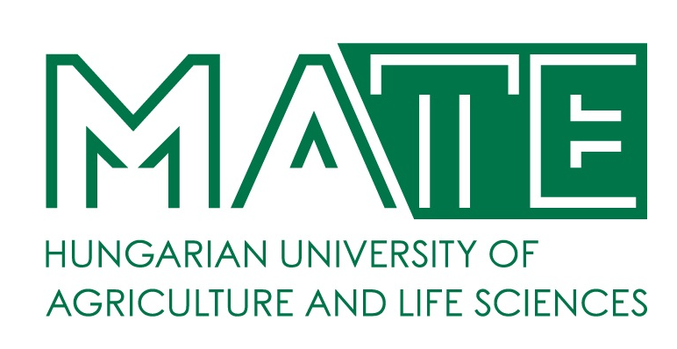
RESPONSIBILITIES |  |  | NAME | CONTACTS | OFFICE HOURS
VICE-RECTOR FOR EDUCATION AND INTERNATIONAL RELATIONS |  | 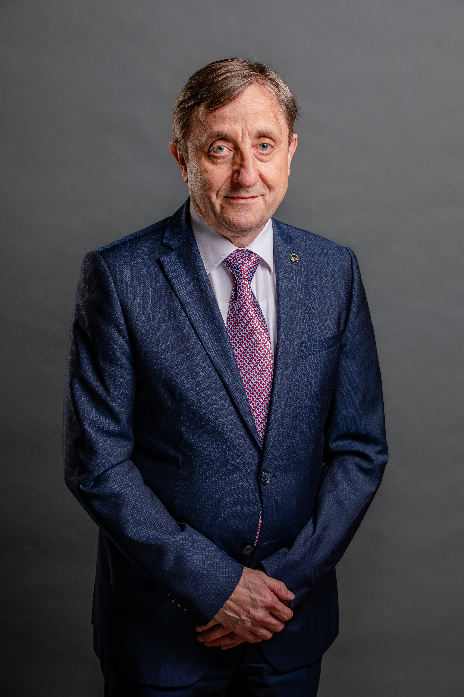​ | Prof. István Szabó, PhD | international@uni-mate.hu
Director of Directorate for International Relations and Development |  | 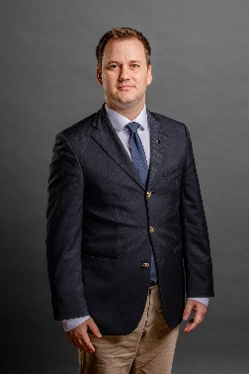​ | Dávid Békési | mateglobal@uni-mate.hu
Head of Secretariat of Directorate for International Relations and Development |  |  | Melinda Petra Dora | dora.melinda.petra@uni-mate.hu
International Coordinator of Centre for International Strategy and Coordination |  |  | Vivien Filó | filo.vivien@uni-mate.hu
International Coordinator of Centre for International Strategy and Coordination |  |  | Olga Taninecz | taninecz.olga@uni-mate.hu
International Coordinator of Centre for International Strategy and Coordination |  |  | Zákányi Krisztina | zakanyi.krisztina@uni-mate.hu  Budapest, Villányi út 35-43. Building K Room 218 Phone: +36 1 305 7275
Head of Centre for International Education  Institutional coordinator (Erasmus, CEEPUS) |  | 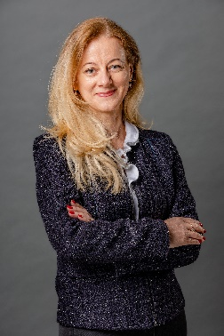 | Zsuzsanna Tarr, PhD | tarr.zsuzsanna@uni-mate.hu  Gödöllő, Main building, room 2071.  Phone: +36 28 522 000 / 3216 | Mon-Wed  13:30-15:00
 | GÖDÖLLŐ CAMPUS – HEADQUARTERS
Stipendium Hungaricum (SH)  Institutional coordinator |  | 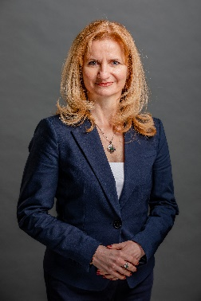 | Csilla Kánai | kanai.csilla@uni-mate.hu  Gödöllő, Main building, room 2064.  Phone: +36 28 522 000 / 3219 | Mon-Wed  13:30-15:00
Student Services coordinator – non-educational issues  (SH, SCYP, DFP, FAO, MISP, Self-finance) |  | 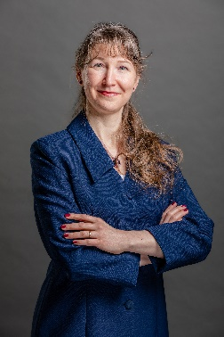 | Judit Tallárom-Czingili | tallaromne.czingili.judit@uni-mate.hu  Gödöllő, Main building, room 2070.  Phone: +36 28 522 000 / 3222 | Mon-Wed  13:30-15:00
International coordinator (FAO, self-financing students) |  | 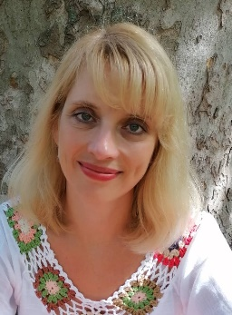 | Kinga Püspök-Szabados | puspokne.szabados.kinga@uni-mate.hu  Gödöllő, Main building, room 2070.  Phone: +36 28 522 000 / 3241 | Mon-Wed  13:30-15:00
International coordinator (MISP, SH, DFP) |  | 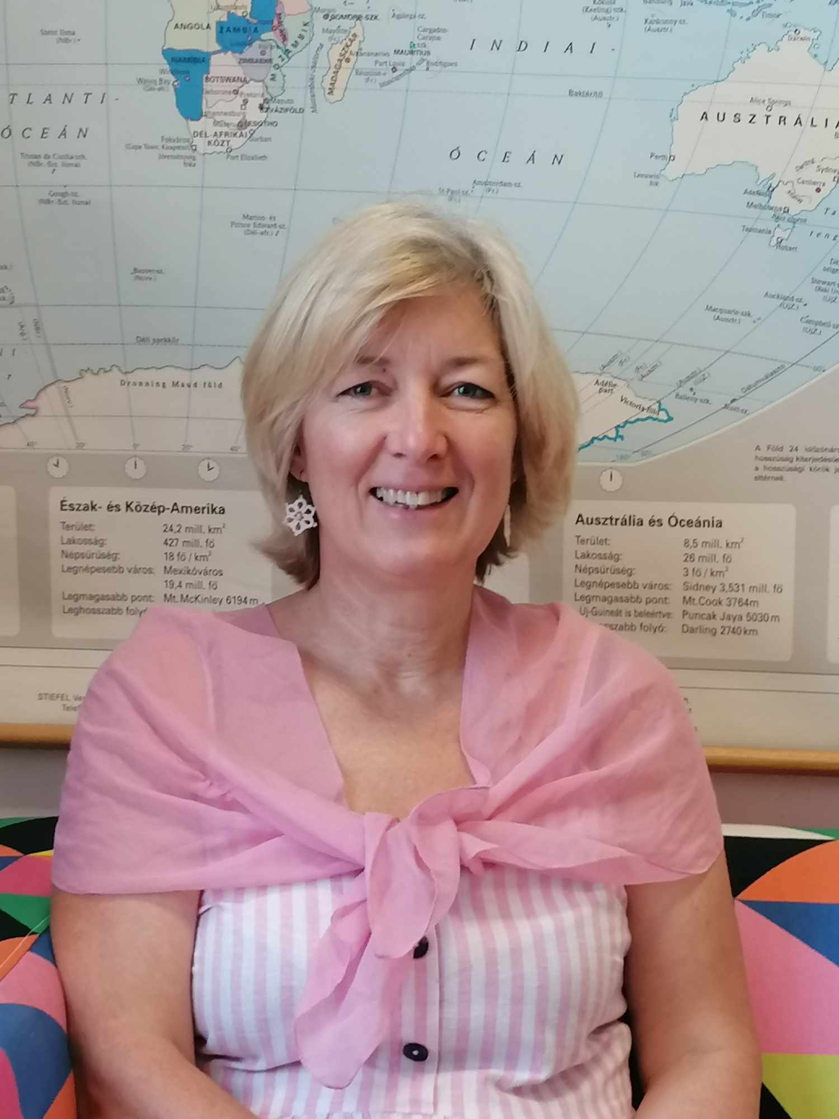 | Zsuzsanna Tassy | tassy.zsuzsanna@uni-mate.hu  Gödöllő, Main building, room 2067.  Phone: +36 28 522 000 / 3265 | Mon-Wed  13:30-15:00
Erasmus coordinator for incoming students and staff  Mentor Coordinator |  | 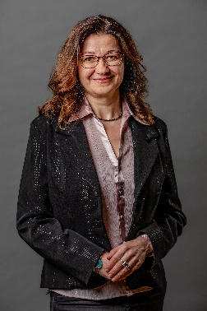 | Edit Szabadszállási | erasmus-in-godollo@uni-mate.hu  Gödöllő, Main building, room 2067.  Phone: +36 28 522 000 / 3221 | Mon-Wed  13:30-15:00
Erasmus coordinator for outgoing students and staff |  | 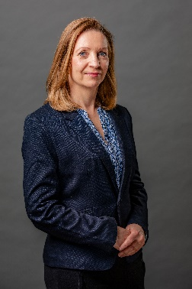 | Beáta Farkas | erasmus-out-godollo@uni-mate.hu  Gödöllő, Main building, room 2066.  Phone: +36 28 522 000 / 3217 | Mon-Wed  13:30-15:00
Erasmus+ International Credit Mobility coordinator |  | 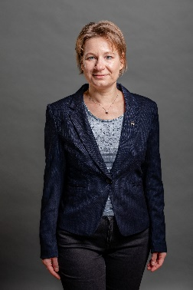 | Zsuzsanna Heltai | heltai.zsuzsanna@uni-mate.hu  Gödöllő, Main building, room 2065.  Phone: +36 28 522 000 / 3218 | Mon-Wed  13:30-15:00
DAFM, emPLANT coordinator |  | 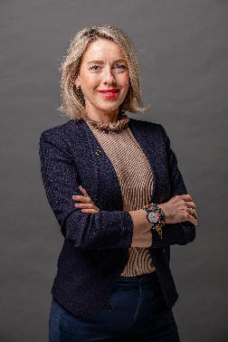 | Zita Batiz | batiz.zita@uni-mate.hu  Gödöllő, Main building, room 2065.  Phone: +36 28 522 000 / 3214 | Mon-Wed  13:30-15:00
Educational coordinator, Head of international unit:  BSc in Business Administration and Management  BSc in Mechanical Engineering  MSc in Mechanical Engineering  MSc in Engineering Management  MSc in Leadership and Management |  |  | Enikő Prokaj, PhD | prokaj.eniko@uni-mate.hu  Gödöllő, Aula Building, room 104.  Phone: +36 28 522 000 / 3210 | Mon, Wed, Thurs  09:00-12:00
Educational coordinator:  Erasmus Mundus Master Programme in Plant Breeding - emPLANT+  Danube Agrifood Joint Master (DAFM)  MSc in Crop Production |  | 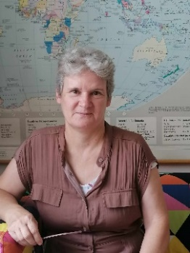 | Andrea Nagy | nagy.andrea.to@uni-mate.hu  Gödöllő, Aula Building, room 104.  Phone: +36 28 522 000 / 3210 | Mon, Wed, Thurs  09:00-12:00
Educational coordinator:  Hungarian Preparatory Course  MSc in Supply Chain Management  MSc in Finance  MSc in Rural Development Engineering |  | 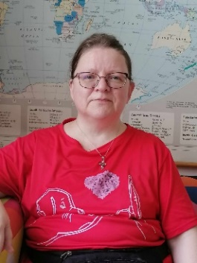 | Judit Gordos | gordos.judit@uni-mate.hu  Gödöllő, Aula Building, room 105.  Phone: +36 28 522 000 / 3259 | Mon, Wed, Thurs  09:00-12:00
Educational coordinator:  BSc in Environmental Engineering  BSc in Agricultural Engineering  BSc in Wildlife Management Engineering  MSc in Environmental Engineering  MSc in Agricultural Biotechnology  MSc in Agricultural Water Management Engineering  MSc in Wildlife Management Engineering |  | 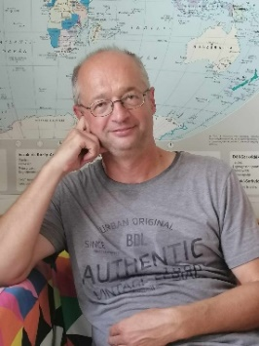 | Henrik Lénárd | lenard.henrik@uni-mate.hu  Gödöllő, Aula Building, room 105.  Phone: +36 28 522 000 / 3259 | Mon, Wed, Thurs  09:00-12:00
Doctoral and Habilitation Centre,  Head of Centre |  |  | Mónika Hajdú | hajdu.monika@uni-mate.hu  Gödöllő, Dormitory B building, ground floor, room 41.  Phone: +36 28 522 000 /3280
Doctoral and Habilitation Centre, International coordinator, Buda and Gödöllő Campus |  |  | Edit Simáné Dolányi | simane.dolanyi.edit@uni-mate.hu  Gödöllő, Dormitory B building, ground floor, room 41.  Phone: +36 28 522 000 /3279 | Mon-Thurs  8:00-12:00
MATE Dormitory Student Coordinator Szent István Campus – Gödöllő |  |  | Beáta Kárpáti | karpati.beata@uni-mate.hu  Gödöllő, Dormitory B building, ground floor, room 43  Phone: +36 28 522 000 / 2071 | Mon-Thurs  8:00-16:00
MATE Dormitory Student Coordinator Szent István Campus – Gödöllő |  |  | Orsolya Horváth | horvathne.horvath.orsolya@uni-mate.hu  Gödöllő, Dormitory B building, ground floor, room 43  Phone: +36 28 522 000 / 2071 | Mon-Thurs  8:00-16:00
Library in Gödöllő |  |  | Szilvia Molnár | https://uni-mate.hu/en/mate/university-library-and-archives | Mon-Thurs  8:00-18:00  Fri  8:00-14:00
E-learning expert |  |  | Judit Gyulai | https://uni-mate.hu/en/mate/university-library-and-archives/e-learning
 | BUDA CAMPUS
Buda Campus  SCYP Institutional Coordinator  International coordinator (SH, DFP, FAO, MISP, Self-finance) |  |  | Krisztina Nagy | nagy.krisztina@uni-mate.hu  Budapest, Villányi út 35-43. Building K Room 218 Phone: +36 1 305 7275 | Mon, Thurs 9:00-12:00  Tue, Wed 13:30-16:00
Buda Campus  International coordinator (Erasmus, CEEPUS) |  |  | Zsuzsanna Erős-Tárczy | eros-tarczy.zsuzsanna.eva@uni-mate.hu  Budapest, Villányi út 35-43. Building K Room 218 Phone: +36 1 305 7275 | Mon, Thurs 9:00-12:00  Tue, Wed 13:30-16:00
Buda Campus  International coordinator - Erasmus+ International Credit Mobility for incoming, outgoing students and staff |  |  | Eszter Somogyi- on maternity leave | somogyi.eszter@uni-mate.hu  Budapest, Villányi út 35-43. Building K Room 205 Phone: +36 1 305 7274 | Mon, Wed:  13:30-15:30  Tue, Thurs:  9:00-11:00
Buda Campus Educational coordinator  BSc and MSc Horticulture engineering |  |  | Magyar Beáta | magyar.beata@uni-mate.hu  Budapest, Villányi út 35-43. Building K, ground floor, Room 2  Phone: +36 1 305 7211 | Mon, Wed, Thurs:  9:00-12:00
Buda Campus Educational Coordinator  BSc of Food Engineering  MSc of Food Science and Technology Engineering  MSc of Food Safety and Quality Engineering |  |  | Petra Antal | antal.petra@uni-mate.hu  Budapest, Villányi út 35-43. Building K, ground floor, Room 4  Phone: +36 1 305 7198 | Mon, Wed, Thurs:  9:00-12:00
Buda Campus Educational Coordinator  BA and MA Landscape  MSc Agricultural Biotechnology |  |  | Rebeka Annus | annus.rebeka@uni-mate.hu  1114 Budapest, Villányi út 29-43.Building K, ground floor, Room 2  Phone: +36 1 305-7211 | Mon, Wed, Thurs:  9:00-12:00
Buda Campus  Somogyi Imre Dormitory  Head of Dormitory |  |  | Ildikó Fedor | buda.kollegium@uni-mate.hu  1118 Budapest, Szüret utca 2-18. | Mon-Thurs  11:00-15:00  Fri 11:00-13:00
 | KAPOSVÁR CAMPUS
Kaposvár Campus  International Coordinator – SH, SCYP, Self-finance, MISP |  | 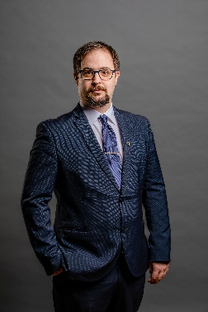 | Péter Csősz | csosz.peter@uni-mate.hu  Kaposvár, Old building, ground floor, room 18.  Phone: +36 82 505 800 / 2653 | Mon – Thurs  13:30 – 15:00
MATE Hostel Student Coordinator Kaposvár Campus (New Dormitory and Csukás Zoltán Dormitory) |  |  | Kitti Kolber - on maternity leave | kolber.kitti@uni-mate.hu  7400 Kaposvár, Guba Sándor u. 40.  Phone: +36 82 505 832
 | GYÖNGYÖS CAMPUS
Gyöngyös Campus International Coordinator (SH, SCYP, MISP, Self-finance) – on maternity leave |  |  | Dóra Póka – on maternity leave | poka.dora@uni-mate.hu  3200 Gyöngyös, Mátrai str 36.  A building I. floor / room 1.203  +36 37 518 305 | Mon, Wed, 8.00-11.30  Tue, Thurs 13.00-15.30
Gyöngyös Campus Educational coordinator |  |  | Barbara Tátrainé Biró | tatraine.biro.barbara@uni-mate.hu  3200 Gyöngyös, Mátrai u. 36. Building A, 1st floor, room 1.206  Phone : +36 37 518-394 | Mon, Wed, 8.00-11.30  Tue, Thurs 13.00-15.30
MATE Hostel Student Coordinator Gyöngyös Campus (Károly Róbert Student Hostel) |  |  | Márk Lakatos | lakatos.mark@uni-mate.hu  3200 Gyöngyös, Mátrai u. 36. Building A, 1st floor, room 1.203  +36 37 518 305 | Tue, Thurs 13.00-15.30  Tue, Thurs 13.00-15.30
 | GEORGIKON CAMPUS – KESZTHELY
Georgikon Campus International Coordinator (SH, FAO, MISP, Self-finance Erasmus) |  |  | Adrienn Soós – on maternity leave | international.georgikon@uni-mate.hu  soos.adrienn@uni-mate.hu  8360 Keszthely, Deák Ferenc utca 16.  Building ’A’, second floor, room 277  Phone: +36 83 545 148 | Mon-Fri  8:00-12:00
International Coordinator (Pannonia, Self-finance Erasmus) |  |  | Beáta Zsankó-Bődör | international.georgikon@uni-mate.hu  8360 Keszthely, Deák Ferenc utca 16.  Building ’A’, second floor, room 277  Phone: +36 83 545 148 | Mon-Thurs  8:00-12:00
International Coordinator (SH, FAO, MISP, Self-finance Erasmus) |  |  | Budai-Koncz Mercédesz | budai.koncz.mercedesz@uni-mate.hu | Mon-Thurs  8:00-12:00
MATE Pethe Ferenc Student Hostel  Coordinator - Georgikon Campus |  |  | György Pásztor | pasztor.gyorgy@uni-mate.hu  8360 Keszthely, Deák Ferenc utca 16.  Building ’A’, second floor, 268  Phone: +36 83 545 155 | Mon-Wed  8:00-12:00

